**DRAFT OUTLINE: GLOBAL STRATEGY ON THE ECONOMICS OF HEALTH FOR ALL**

**Draft 0**

This document is an outline for regional consultation and experts prior to member state consultation. None of the text is decided, the aim is to present a cohesive document that provokes questions, comments and suggestions.

Please note that WHO strategies are high level 5000 word-documents that outline broad areas of work, for member states, WHO and other stakeholders, but do not describe the detailed actions under each, which remain context specific. For an example of a previous strategy please see: <https://www.who.int/publications/i/item/9789240080515>

This document lists all the areas to be included with a short description of each in preparation for member state consultation.

It builds on instructions to WHO from the EHfA resolution and will be used as the basis for a WHO-wide work programme to support member states. In this case the EHfA brings together action across WHO, and therefore it is important that all relevant areas are included in the strategy.

**The important inputs sought at this stage are:**

Does the strategy represent the core objectives and mandate established in the resolution?

Does the strategy include all the relevant directions for countries to achieve its objectives, considering current global guidance and resources in this space?

Are there important actions that are missed under each direction?

# TABLE OF CONTENTS

TABLE OF CONTENTS 2

Foreword 3

Acknowledgements 3

Abbreviations 3

Executive Summary 3

Introduction 4

Why we need a global strategy on the economics of health for all? 4

Foundations 5

Audience 6

Strategy development 6

A global strategy to lead us to 2030. 7

Vision 7

Guiding principles 7

Objectives 8

Strategic Directions 9

Economic Policy for HfA 10

Value and invest in HfA 14

Financing for HfA 17

Capacity for EHfA 20

Evidence for EHfA 23

Strategy implementation 25

References 26

# 

# Foreword

# Acknowledgements

# Abbreviations

# Executive Summary

# Introduction

## Why we need a global strategy on the economics of health for all?

**Persistent inequalities challenge the achievement of Agenda 2030.**

Despite improvements in Universal Health Coverage (UHC) under Sustainable Development Goal 3 (SDG 3) “Ensure healthy lives and wellbeing for all”, more than half of the global population still lacks access to essential health services, and one in four people experiences financial hardship due to out-of-pocket health costs (1). Equally worrisome is weak progress made in other SDGs that underpin the many other determinants of health. Global poverty reduction, and related indicators have stalled and one-fifth of the world’s population live in countries with high inequality (2).

These challenges are unfolding in a world facing social, economic and environment transformation that is reshaping the foundations of health and wellbeing for all: rapid technological change, debt and fiscal constraints, altering demographics, urbanization, changing nature of work, and climate and environmental crisis. Systematic national and globally coordinated change in the economics of health is needed to create the conditions for sustainable, inclusive and healthy societies.

**Interdependence between health and economic systems.**

Health and prosperity are key to individual and collective wellbeing: they allow individuals and societies to pursue the many goals they value. The enjoyment of the highest attainable standard of health is a human right without distinction of race, religion, political belief, economic or social condition. Just like for some other rights, progress depends, to some extent, on conditions and resources provided by economic systems. A healthy population is an asset for meaningful economic growth and long-term stability and resilience of communities and societies. Economic growth generates resources to invest in health and living conditions conducive to better health but may not always benefit the health of all equitably.

**Transformative potential of an Economics of Health for All approach**

To realize Health for All (HfA) – a state in which health and wellbeing are within the reach of every person through their lives - an Economics of Health for All approach (EHfA) is needed. HfA depends on how resources are generated, distributed and invested. Mission-orientated economic policies and actions should be driven by their capacity to support sustainable, inclusive economic growth and by their ability to promote, protect and ensure health and wellbeing across all segments of society. This approach recognizes health, wellbeing and economic welfare as interdependent and inseparable dimensions of societal progress. Health and wellbeing are elevated as goals that shape how economies function, deliver value and define success, both as means and as ends.

EHfA shapes how economic systems, governments and corporations influence health, and repositions health within core economic objectives, providing a foundation for effective policy, investment and actions towards societal progress. It promotes coordinated actions across all levels of government and sectors to design, assess and implement economic policies aligned with HfA. EHfA requires fundamental shifts for the long-term transformation of economic systems, but immediate actions as proposed in this Strategy can make a difference now and for future generations.

## Foundations

The Global Strategy on the EHfA (GSEHfA) builds and complements other WHO resolutions (Figure 1), providing a guiding mission that links HfA to economic policy-making, investments and actions by governments and other actors. It draws on work from the WHO Council on the Economics of Health for All (Figure 2), urging for fundamental shifts in economic thinking and putting forward recommendations to change the way health is valued, measured, distributed and governed (3).

**Figure 1:** Examples of related, recent WHA resolutions

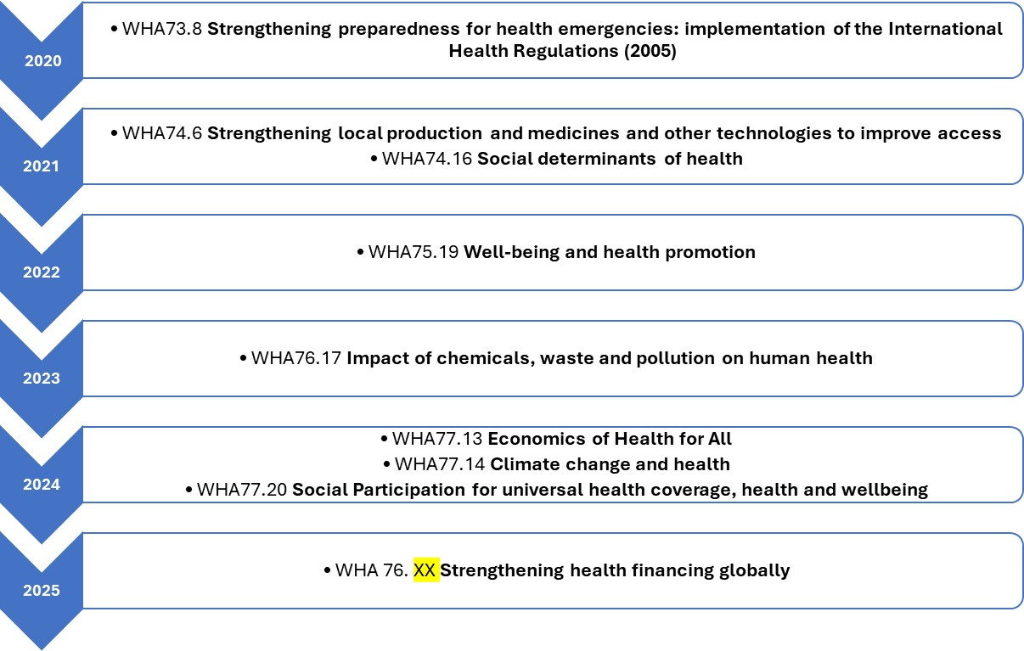

**Figure 2**: Preliminary framework for building up an economy for health(4)

EHfA recognises the interaction between the economy and health at structural, social, systemic and household levels. It emphasizes that economic factors at various levels fall under government jurisdiction, encompassing ministries, parliaments, legal systems, and other institutions that influence finance and economic policies, as well as within other sectors, including civil society and the private sector. EHfA also builds on other WHO’s initiatives in collaboration with Member States and partners to promote HfA through actions on their determinants (5–10).

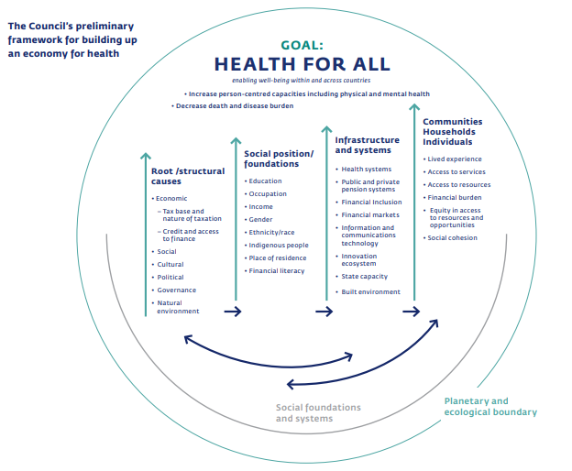

## Audience

The GSEHfA is primarily intended for use by heads of state, ministers, governmental officials, central bank leaders and politicians who design, shape or influence economic policies that affect HfA either directly or indirectly at subnational, national, regional and global levels. The GSEHfA also concerns the wide array of stakeholders who can promote the adoption of an EHfA approach, including citizens, civil society organizations, labour unions, statistical offices, think-tanks and academia, international organizations, development banks, aid actors, medias, and private sector and industry representatives.

## Strategy development

The GSEHfA was developed by WHO’s Health Financing and Economics department in collaboration with the Organization’s three levels and through global and regional consultations with Member States and external stakeholders.

# A global strategy to 2030

The GSEHfA has been developed as a guiding framework for the health sector to engage in economic and financial policy and sectors, on the request of member states. The GSEHfA proposes an overarching framework that positions health and wellbeing at the centre of economic policy and investment. It redefines the purpose of the economy as serving people and describes an EHfA to orient and align economic policies with the goal of promoting, protecting and restoring HfA, offering a new approach grounded in equity and sustainability. While not exhaustive, it addresses major upstream structural determinants of health and supports ongoing policy innovation for reducing health inequities at subnational, national, regional and global levels.

## Vision

**‘A world in which the economy serves health for all’**

EHfA envisions the economy as **a people-centred system** where economic policies prioritize the health and wellbeing of all, both now and in the future. These policies go **beyond average** measures to address disparities; reflect the **values of the populations** they serve and guide public and private investments toward securing a **healthy future for current and future generations**.

## Guiding principles

Seven guiding principles underpinned the development of the GSEHfA.

**People centred**

Economic policies and actions are designed with and for people, recognizing their diverse needs and lived experiences, and acknowledging agency as a central aspect of health and wellbeing.

**Social participation**

People actively participate in policy and investment decisions that affect their lives. Inclusive, transparent and meaningful social participation across all layers of collective actions builds trust and ensure policies and services reflect the needs and aspirations of all communities, especially those most excluded.

**Equity**

The pursuit of inclusive and equitable approaches for H4A, aligned with justice for all. Special attention is given to the social gradient in health, implying universalism across the whole population and to factors that affect populations in vulnerable or marginalized situations, including migrants, refugees and displaced persons.

**Gender equality**

Economic systems and policies should actively promote equal rights, opportunities, and outcomes for people regardless of gender by addressing structural inequalities and enabling full and equitable participation in all spheres of life and across the life course.

**Country-led**

Sustainable development and progress towards HfA must be driven by country leadership with national and subnational governments and institutions at the centre of planning, decision-making and accountability using a whole of government approach. External support should align with national priorities, strengthen local capacity and respect country contexts to ensure ownership, effectiveness and long-term impact.

**Evidence-informed**

Policy and actions should be grounded in the best available evidence – combining data, research and local knowledge to inform decisions responsive to real-world needs. An evidence-informed approach values continuous learning, rigorous analysis, multidisciplinary collaboration, adaptability in the face of complex challenges and commitment to impact.

**Environmental sustainability**

Decisions and actions by governments and stakeholders must protect and sustain the natural environment for current and future generations.

## Objectives

The GSEHFA’s objectives are to:

* **Orientate economic systems and institutions** to the benefit of health and prosperity of populations
* **Improve health and reduce health inequality** by ensuring economic policies and investments value health.
* **Empower countries to make informed policy choices** and take concrete actions that consider both health and the economy.
* **Coordinate global, regional and domestic health and economic actors** behind the common goal of health and wellbeing for all.

## Strategic Directions

EHfA requires action across five interconnected strategic directions (Fig. 3). Under each direction, priority actions are proposed for consideration, adaptation and prioritization by countries depending on their own contexts. Some of these actions may require international coordinated actions and country support.

**Figure 3:** Vision and strategic directions.

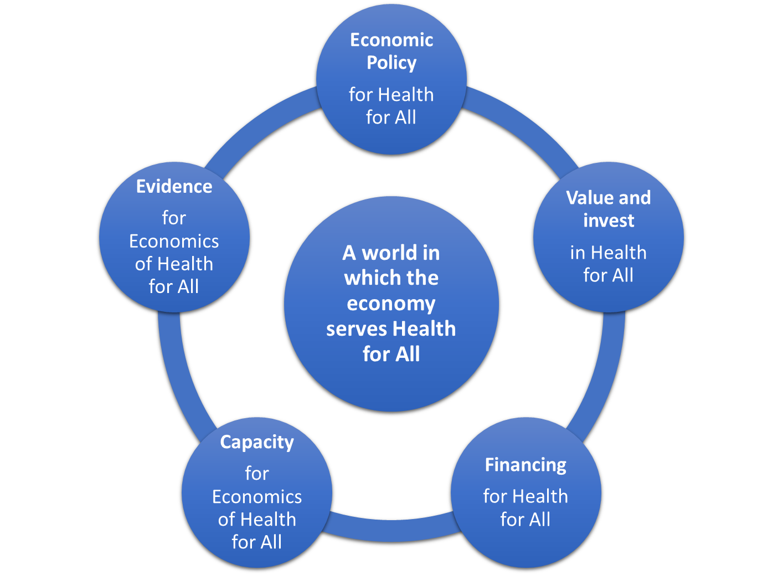

## Economic Policy for HfA

Economic policy on taxation, trade, industry, labour and social protection are key levers for shaping the broader enabling environment needed to achieve HfA (Box 1). This strategic direction focuses on reviewing and realigning core economic policies to actively promote HfA.

**Table 1:** Scope of economic policy areas considered

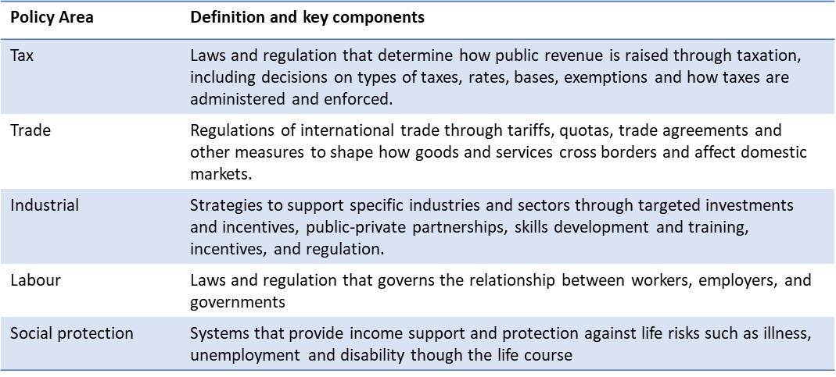

**Figure 4:** Overview of priority actions

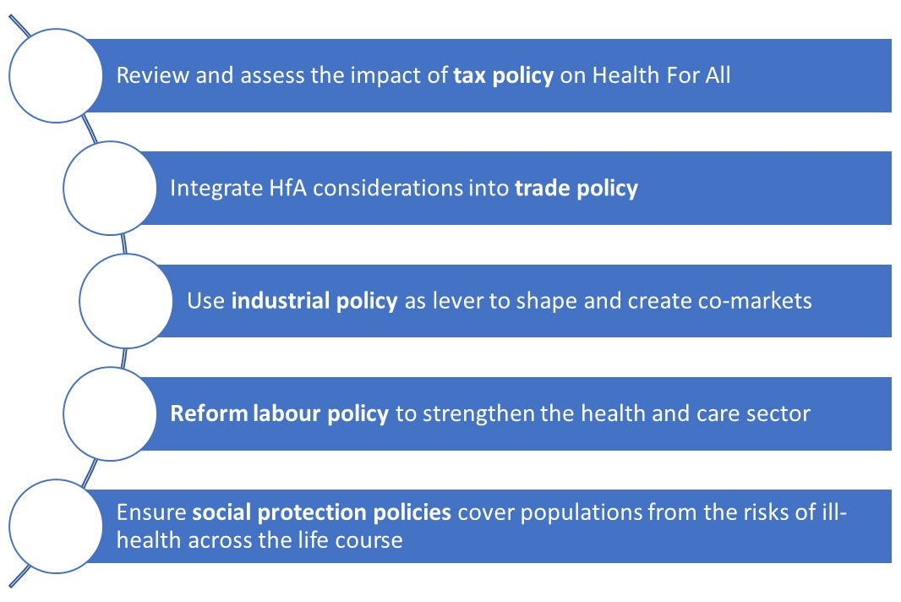

**Review and assess the impact of tax policy on HfA.** Taxation is key to both mobilize revenues to finance for health services and shape inclusive and sustainable economies (Box 1). Analyses of the economic and social costs of current tax systems can help reprogramme tax policy in a way that strengthens domestic revenue mobilisation and ensures social justice (11–13). Well designed and implemented excise taxes for reducing unhealthy goods consumption (including tobacco, alcohol and sugar and sweet beverages) may also substantially improve population health and generate additional revenue (14,15).

**Integrate HfA considerations into trade policy.** Governments can create enabling conditions to ensure public health is incorporated in trade policies. Trade policy can both impact public revenues for health services and help enhance access to essential goods (Box 1) . Various approaches may influence trade policymaking, including gathering and providing evidence, notably from health impact assessments around trade policies, forming multi-country or/and civil society coalitions to protect and enhance access to essential health goods or other commodities that enhance health (16).

**Use industrial policy as lever to shape and co-create markets for HfA.** Governments can orient industrial strategies towards reducing the production and consumption of health-harming products and services. They may use regulation, marketing and advertising restrictions (e.g. nutrition labelling policies) and subsidies tied to decent work conditions and sustainable practices, amongst others (17). Equally important is the regulation of industries which products or services may not be inherently harmful, but which commercial practices may negatively impact public health (e.g. regulating vehicle emissions standards, social media). As major purchasers of goods and services, governments can leverage public procurement to shape markets in support of HfA, for example, by selecting suppliers based on social and environmental criteria (18). Finally, governments can review how to channel public investments more purposively toward HfA, developing public-private innovation ecosystems, ensuring attractive conditions for private investors in public health goods, whilst setting the terms for accessing public funding and market opportunities around product affordability and equitable access (19,20) (Boxes 2 & 3).

**Box 1:** Tax policy reforms in Rwanda(21,22)

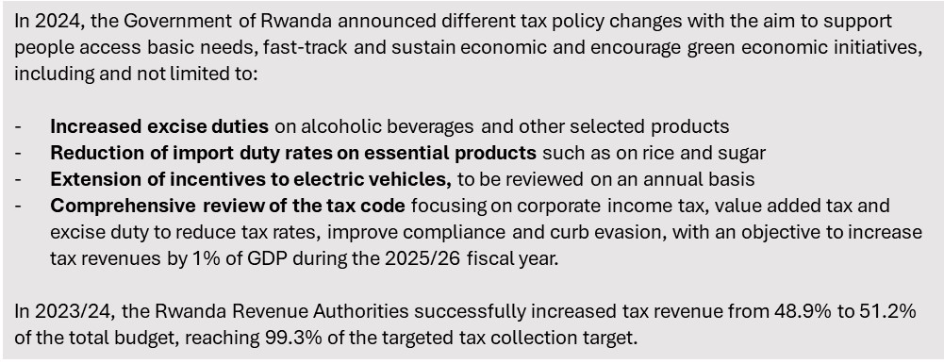

**Box 2:** An investment framework for promoting local antibiotics manufacturing in Ethiopia (23)

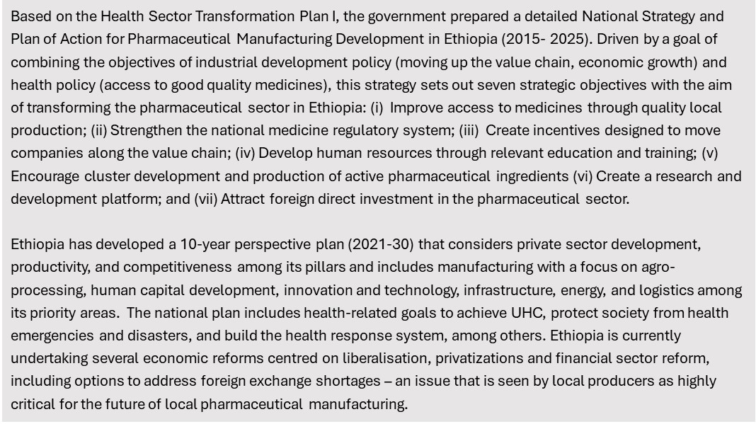

**Box 3:** How government action shaped private sector investment inAustria (23)

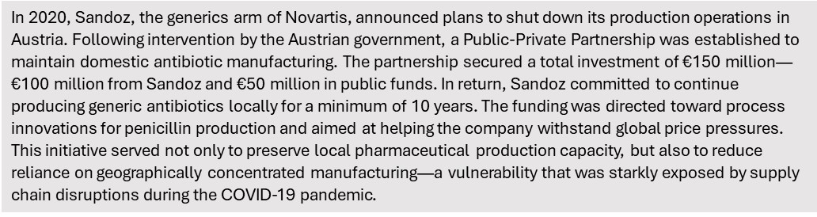

**Reform labour policy to strengthen the health and care sector.** (24,25)

Governments need to prioritize labour policy that address health workforce shortages, skills mismatches and enabling conditions for high-quality, stable jobs in the health and care sector (26). This may include reviewing how labour market policies interact with health, education and trade policy to identify structural barriers and opportunities for improvement. Key reforms may include easing demand and supply constraints through better workforce planning, investing in education and training and aligning service delivery models to support decent employment. Non-health workers in health facilities and informal care workers, predominantly women, play a critical yet often unrecognized role in supporting health systems and advancing HfA. Government can address these gaps by integrating these groups into data and planning systems to ensure visibility in national labour and health strategies whilst enacting inclusive labour policies that recognize and protect informal care work, ensure decent work standards, and promote occupational health and training.

**Ensure social protection policies cover populations from the risks of ill-health across the life course.** Social protection policies must be designed or adapted to offer adequate and reliable support through all stages of life (27), with benefit levels that meaningfully contribute to health and well-being. Their integration into national security frameworks can strengthen resilience during health and economic crises, ensuring continuity of income and access to essential services. Finally, progressing towards UHC demands robust financial protection to prevent individuals and families from falling into poverty due to health-related costs.

**Box 4:** National system of care in Uruguay (28)

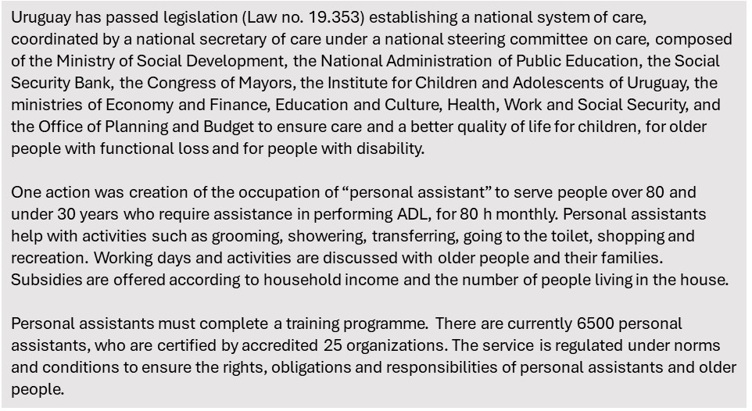

## Value and invest in HfA

This strategic direction focuses on aligning strategic planning and decisions on economic policies and public investments with HfA

**Figure 5:** Overview of priority actions

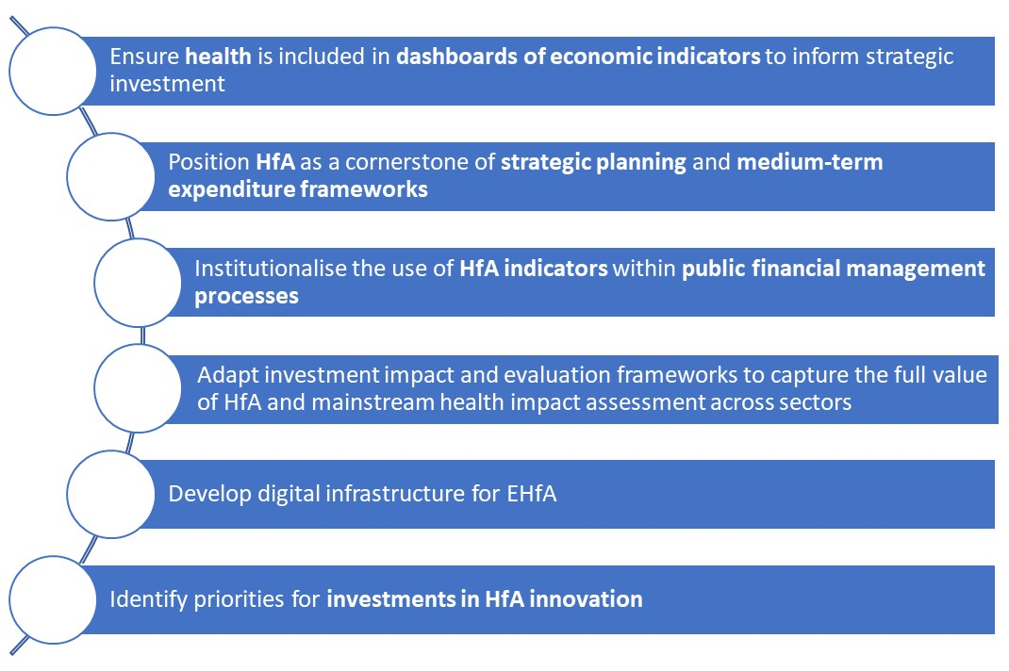

**Ensure health is included in dashboards of economic indicators to inform strategic investment**

People place value on health, wellbeing and economic welfare. However, the relative importance of these dimensions can differ across populations based on cultural, social and economic contexts. Member states can develop their own dashboard of multidimensional indicators, drawing on the SDGs or the WHO’s Operational framework for Health Equity (10) and lessons learnt from other countries (4,29) to support the goal of improving wellbeing in public investments (Box 5)*.*

**Position HfA as a cornerstone of strategic planning and medium-term expenditure frameworks**

HfA needs to be embedded in medium- and long-term development plans within and beyond the 2030 SDG Agenda (Box 5). Coordinated action across all levels of government through Health in All Policies and whole-of-government approaches such as interministerial committees and interdepartmental units is key, supplemented by active engagement with the private sector (30).

**Institutionalise the use of HfA indicators within public financial management processes**

Public financing processes can contribute to effective HfA investment. This includes budgeting strategies that focus on priority indicators and outcomes (Box 5 ), that fully incorporate health improvement generated by all sectors, informing synergies in cross-sectoral investment for health *(30)* and reorienting budgeting in ways that expenditures to priority goals are traceable.

**Box 5:** Measuring what matters in Canada(31,32)

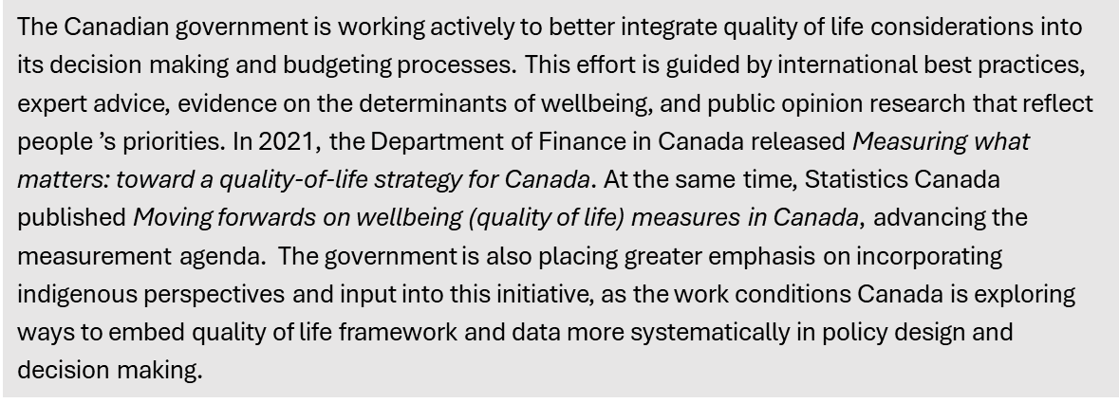

**Adapt investment impact and evaluation frameworks to capture the full value of HfA and mainstream participatory quantitative health impact assessment across sectors**

Comprehensive evaluation frameworks are needed to assess how investments enable people to lead lives they value. Participatory health impact assessments that include equity considerations need to be integrated into economic and sectoral policymaking alongside economic or environmental assessments to ensure health and health equity outcomes are systematically considered. Analytical frameworks commonly used to inform economic policy may also need to be adapted (Boxes 6 & 7).

**Box 6:** Examples of potential joint health and economic analytical frameworks (25,33–36)

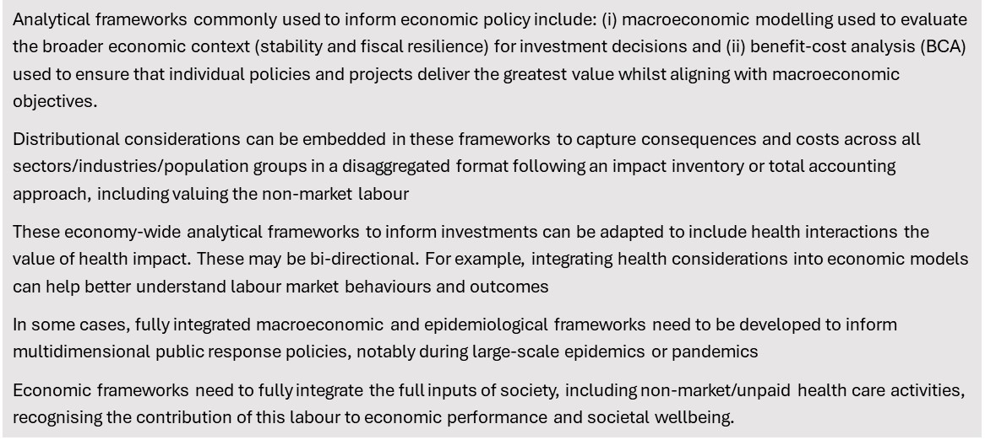

**Box 7:** Modelling the COVID-19 pandemic at the Bank of Italy(37)

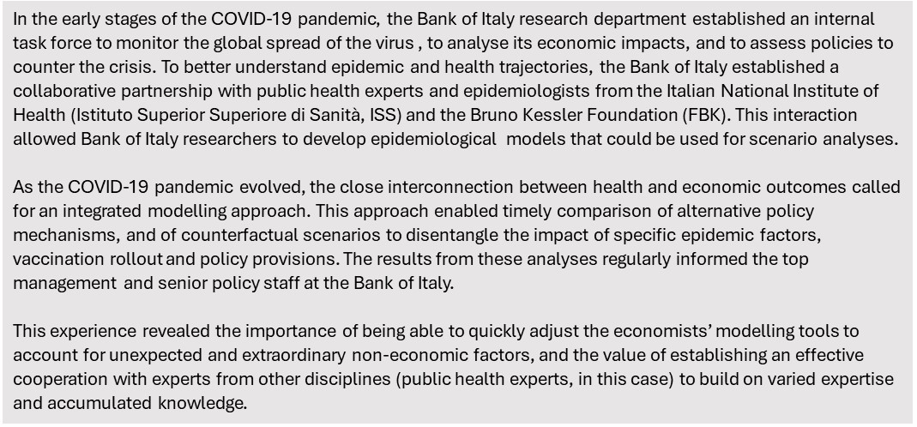

**Develop digital infrastructure for EHfA**

Developments in digital infrastructure should be explored that to improve the data available to inform investments related to EHfA. Initiatives may include, for example, linking datasets on economic indicators with health indicators, both at aggregate and market levels and developing publicly available dashboards supplemented with a digital architecture to consult and engage communities and society.

**Identify priorities for investments in HfA innovation**

To secure future gains for HfA, countries invest in health science, technology and innovation. These investments can impact the economy more broadly. Governments will need to set priority investment areas and working with their research funding bodies to provide catalytic investments to ensure returns to both health and the economy. These priorities will need to align to the EH4A value structures and may require new metrics in terms of how successful research is defined to reflect those values, together with examining and defining the balance between private and public value of those investments.

## Financing for HfA

This strategic direction contains actions to strengthen **both domestic and international financing for HfA**. This repositions Ministries of Finance as guarantors not only of macro-economic stability and growth, but as enablers of healthy and equitable societies.

**Figure 6:** Overview of priority actions

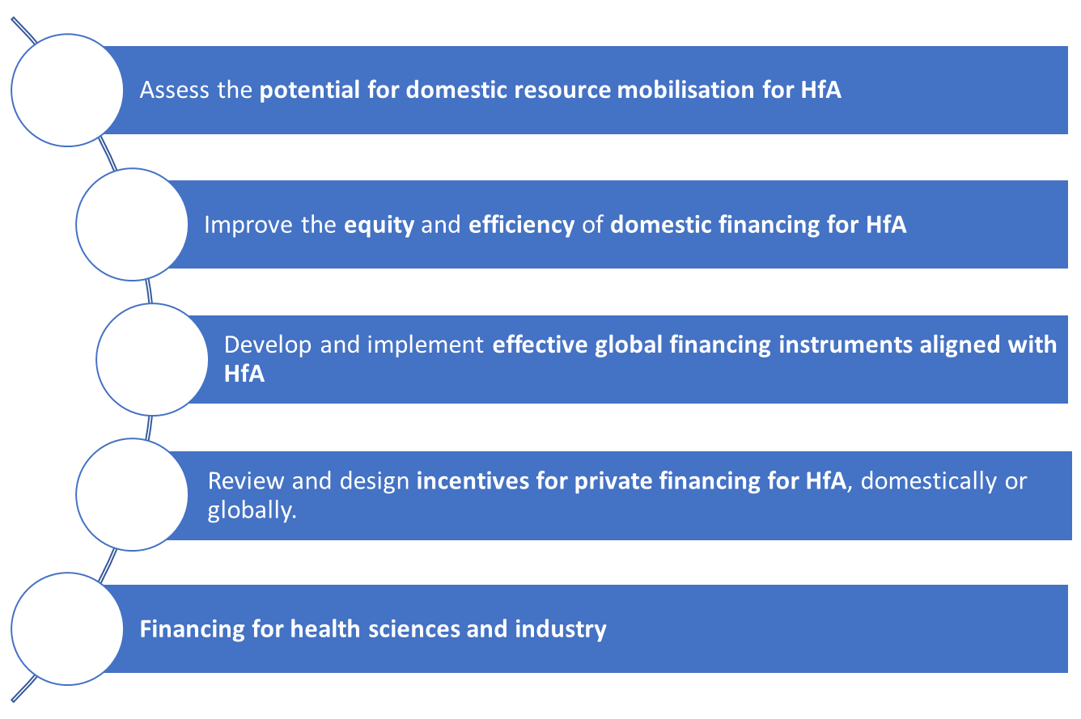

**Assess the potential for domestic resource mobilisation for HfA**

In many countries, mobilizing domestic resources for primary health care (PHC) is needed to ensure an inclusive pathway to achieving UHC and HfA. As above, a key strategy involves increasing general tax revenue by broadening the tax base and reviewing rates (Box 1). To ensure resources effectively reach frontline service providers and communities, ministries of health may establish a dedicated PHC team responsible to mobilize political support during budget negotiation (38) and ensure sufficient resources from health sector budget are allocated to PHC interventions (see next section). Equally important is the pooling of resources across sectors, a central approach to a whole-of-government approach for HfA . Ministries can develop joint sectoral strategies with budget proposals showing contributions to HfA and co-benefits for each sector or/and establish public-private and community collaboration. Similar initiatives can also be undertaken at local levels (Box 8).

**Box 8:** Financing Healthy Cities Initiatives(39)

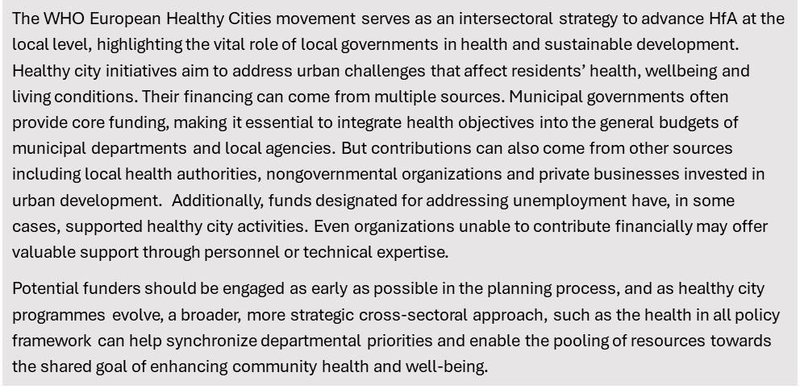

**Improve the equity and efficiency of domestic financing for HfA**

Equity requires that health financing mechanisms are based on ability to pay and need for services, ensuring that the poorest and most vulnerable populations are protected from financial hardship. As above, this demands greater reliance on progressive taxation and pooled financing. At the same time, improving efficiency requires ensuring the allocation of resources is well aligned with HfA alongside the analytics described above, strategic purchasing and better public financial management. For both equity and efficiency, institutionalising participatory decision-making processes such as health technology assessment in health sector and health equity impact assessment are needed to improve domestic financing for HfA.

**Develop and implement effective global financing instruments aligned with HfA**

Further advocacy and co-ordination are required to ensure that global and regional financial instruments assist countries in the strengthening the financing of HfA. The Lusaka agenda is an example of a non-binding agreement supporting unified planning, budgeting and monitoring. The IMF Resilience and Sustainability Facility is an example of a financing facility supporting public health functions for pandemic preparedness. Other opportunities may exist at the level of development banks (e.g. safeguards, HFA as matters of attention for policy-based loans) and at international level (e.g. global tax rules to prevent tax competition and the subsequent erosion of national tax base).

**Review and design incentives for private financing for HfA, domestically or globally.**

Private investors and financiers play a vital role in both funding for health, and health care delivery sector in many countries. There are a range of different policy options that can increase private sector investment in services that have a social impact (eg. social impact bonds), but many have yet to deliver substantial funding. A range of measures (e.g. health-oriented venture capital funds, socially responsible investment certification) may be considered, with due attention to their efficiency and distributive effects. In some of these countries, there is a trend of increasing financialization of health care delivery with concentration through merger, sale to private equity and eventually enlisting on the stock market (40). These market dynamics need to be appraised for their impact on HfA, including their distributional effects.

**Financing for health sciences and industry**

Governments are active investors in science, technology, and innovation for health; and some have built strong ecosystems for health sciences and industry. Such strategic investments and innovation, which can, mobilize both public and private funds, domestic and international, can produce substantial benefit, but may also come with risks and challenges, particularly in ensuring equitable access to essential health products. Throught the sharing of experiences, governments can create successful enterprise environments, build capacities, lever policy tools (e.g., tax credits) to ensure foster investment in health science, which reflects their economic and health priorities.

## Capacity for EHfA

Ministries of Health and other health actors need to develop capacity in EH4A to engage with economic actors. Moreover, public authorities at all levels and across key economic sectors must deepen their understanding of how economic policies, financing and investment impact HfA and strengthen capacity to engage across ministries, agencies, and sectors. This includes developing collaborative approaches for planning, implementation and accountability that harness the expertise of actors across health, finance, trade, industry, labour and social protection, and communities (Box 9).

**Figure 7:** Overview of priority actions

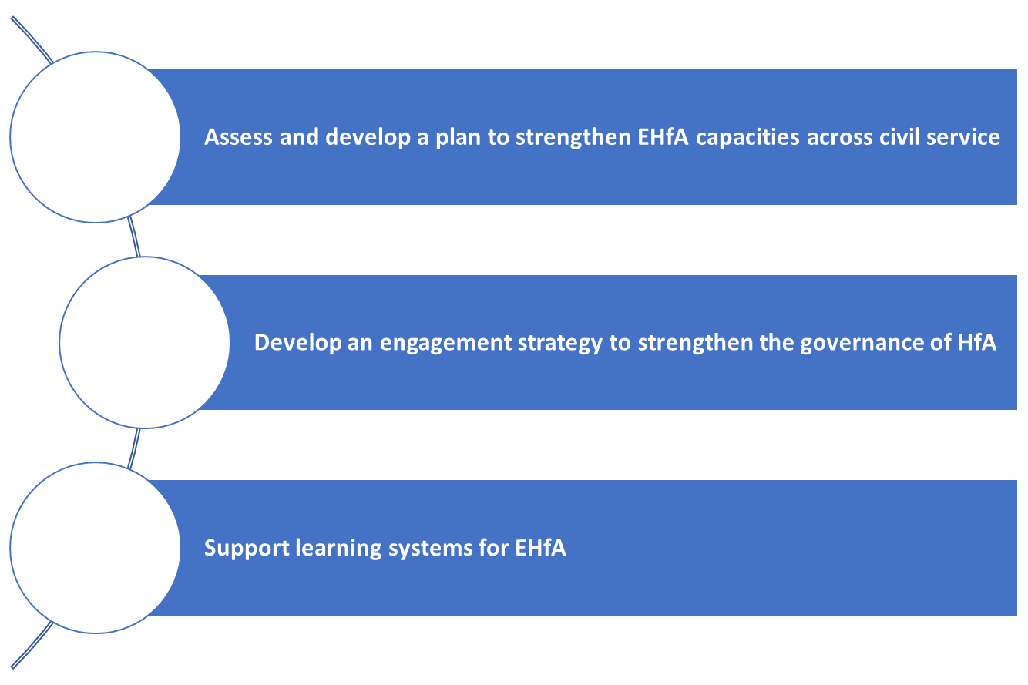

**Assess and develop a plan to strengthen EHfA capacities across civil service**

Health authorities may need to strengthen expertise to engage more effectively with economic authorities during strategic planning, economic policymaking and resource allocation processes. Key capacities for health authorities includes identifying and quantifying key arguments to make more robust investment case in health, understanding the role of health impact assessment across sectors, as well as using economic evidence and participatory decision-making processes to inform resource allocation and investment within the health sector. At both national and subnational levels, public health and clinical workers need to be equipped by a strong understanding of how economic systems influence the effectiveness of their actions. It may also involve training health workers in identifying and addressing social factors, promoting not only behavioural change to reduce exposure to disease risk factors but facilitating access to social services. Capacity building efforts in EHfA should also target civil servants working outside the health sector, providing them with better understanding of the co-benefits of improving health equity for their own sector and the implications of their policy on HfA, amongst others (Box 9). Many of these capacities may already exist but may do so in silos, limiting their impact. Mapping existing capacities and identifying gaps can help inform the development of a targeted pan to build and pool capacities at the country or regional level (41).

**Box 9:** Illustrative EHfA capacities

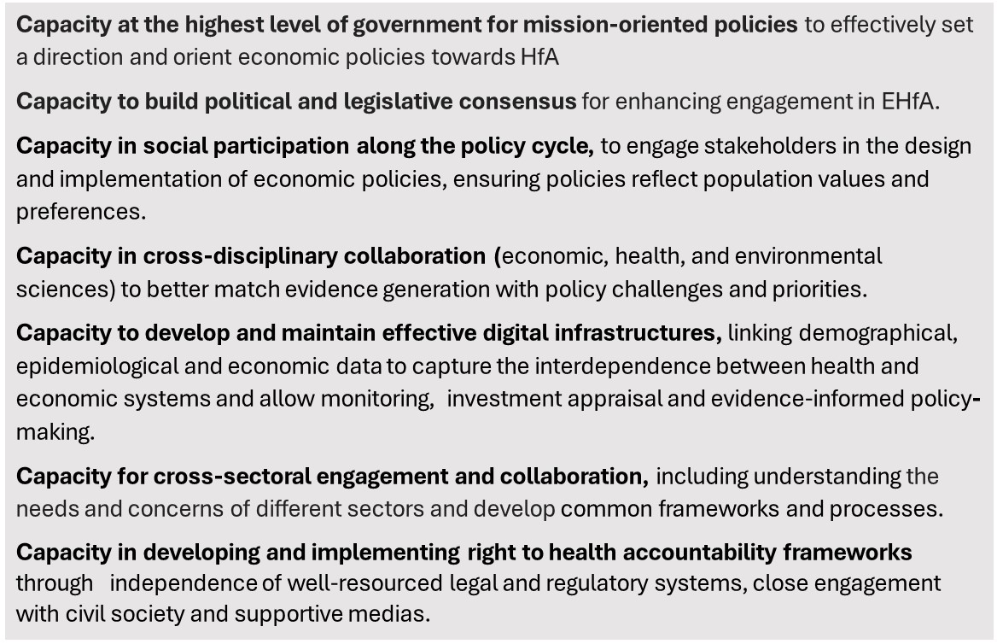

**Develop an engagement strategy to strengthen the governance of HfA**

Meaningful engagement between health and economic sectors needs to ensure joint policies are socially legitimate, rooted in shared values and responsible to diverse needs across society. It requires a coordinated and inclusive approach to policy development, implementation and accountability. An effective engagement strategy needs to bring together government institutions, civil society organization, private sector actors, academic institutions and community groups around the shared vision of HfA. Government can play a key convening role facilitating dialogue across sectors and levels of governance to co-design priorities and align incentives. Civil society can contribute valuable local knowledge, advocacy and accountability mechanism while the private sector can drive innovation and investment aligned with HfA. The strategy should include structured mechanism for participation such as national dialogues, citizen assemblies, patient council as well as clear communication plans, feedback loops and capacity building efforts. Domestic and international platforms should provide mutually supportive networks and community of actors committed, through original solutions, processes, and interventions, to HfA (42).

**Support learning systems for EHfA**

EHfA requires a transition towards new collective goals which will require constant attention to generating intelligence both on new challenges (e.g. healthy ageing) and on what works to address them. In every country, establishing a learning health system - defined as a health system skilled at creating, acquiring, interpreting, transferring, and retaining knowledge, and at purposefully modifying its behaviour to reflect new knowledge and insights – should be an area of investment (43). A large array of actions can be considered. For instance, member states can establish ‘policy labs’ that experiment with integrated solutions relevant for the HfA agenda. Globally WHO can work with other partners to strengthen normative products and evidence informed global public goods, sharing knowledge and expertise and enabling countries to learn from one another. Likewise, linking networks with global economic fora (such as the G20) can be facilitate emerging approaches for EHfA to inform global co-ordination around health and economic policy.

Learning systems must also reflect the local, informing solutions at grassroots and community level, and ensuring those lessons reach those designing policy action and investment. New platforms may need to be developed to encourage policy makers, researchers and experts (mayors, civil servants, staff of specialised agencies, representatives of labour unions, researchers, etc.) to participate to transnational peer-to-peer learning. It is important to fully document experiences (e.g., case studies) and share lessons, supported by international meetings and study tours.

## Evidence for EHfA

Placing HfA at the centre of national, regional, and global economic policy and action will require a strong commitment to science. It will require the generation of new evidence exploring and further understanding and establishing the linkage EHfA policy and impact. Interdisciplinary research particularly between health, economics and social sciences is key for success, but may require new funding streams, in both academic and operational research communities, in the light of disciplinary silos (Box 10).

**Figure 8:** Overview of priority actions

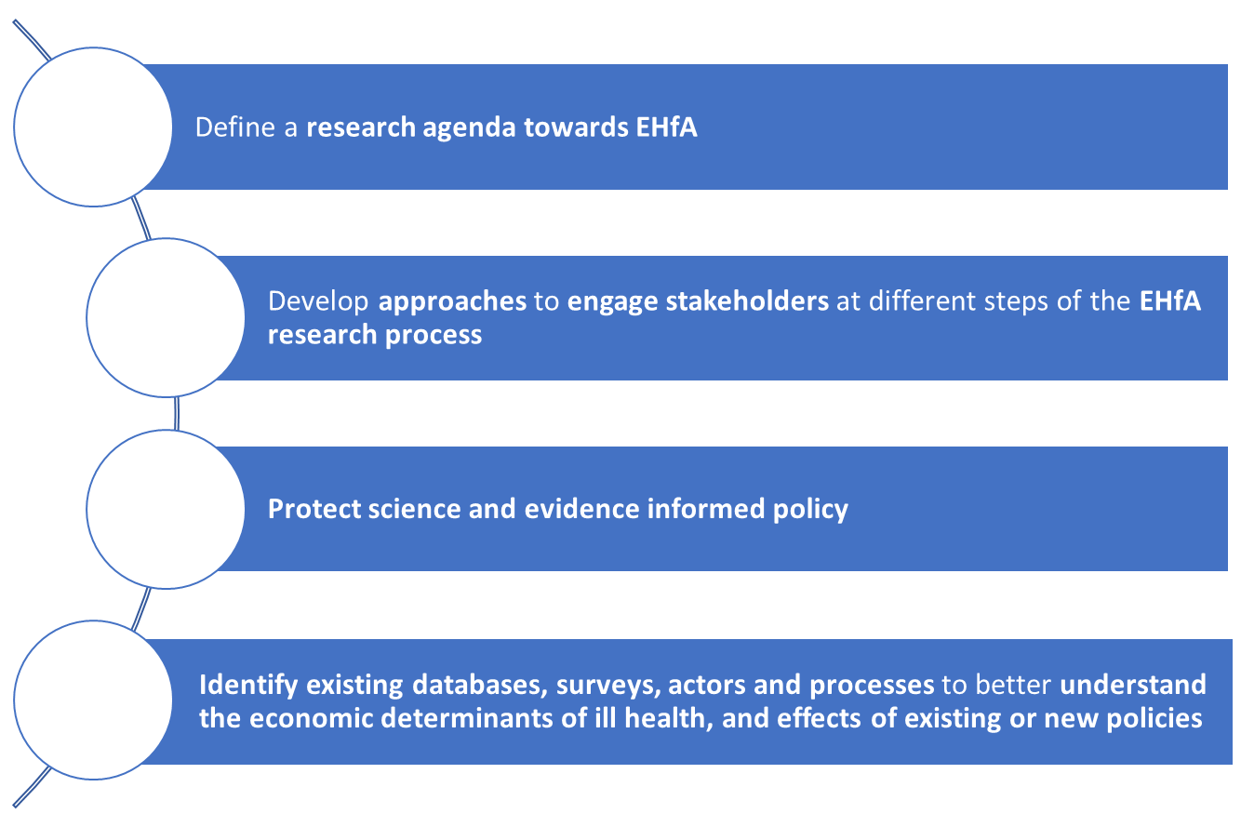

**Define a research agenda towards EHfA**

The EHfA approach is broad and requires further determination and prioritisation of global and national evidence needs. A clear research agenda will help advocate for research funding to inform EHfA as a research priority. The definition of this research agenda must be conducted together with both policy makers and those stakeholders and communities potentially impacted by the research or policies the research is aimed to inform. The research agenda should be closely linked to and contribute to a structured emergence of the evidence and provide a roadmap for the joint effort by policymakers, funders, academics and the civil society. Some examples of potential priority research gaps are presented in Box 10.

**Develop approaches to engage stakeholders at different steps of the EHfA research process**

Engaging stakeholders at different stages of the research process is essential for ensuring that evidence is relevant, trusted and used effectively. Approaches should be developed to involved policymakers, practitioners, civil society, affected communities and the private sector throughout the research cycle. Inclusive engagement helps align research with real world needs and builds shared ownership of results. Approaches may include, for example, co-design workshops, advisory groups, policy dialogues and community consultations.

**Box 10:** Examples of research gaps

|  |
| --- |
| * Understanding experiences in developing and using dashboard of multidimensional indicators for policymaking * Developing composite metrics of social progress to supplement traditional economic metrics * Reviewing the impact of fiscal, monetary, industrial and trade policies and of economic structures on HfA * Review experiences in transitioning towards EHfA and wellbeing economies at subnational and national levels. * Reviewing experiences and lessons learnt in public-private partnerships and investment models for HfA at national and subnational levels * Developing a health taxonomy to classify economic activities based on their impact against a common set of public health priorities and inform the financing of HfA *(44)* * Developing a maturity framework to assess country capacities on EHfA * Explore whether monetary policy is fit for purpose during health shocks * Policy solutions and processes for countries to transition away from health-harming industries and fossil fuels. * Exploring how aging, health and the economy interact and how different sector contribute to health and wellbeing at different life stages |

**Protect science and evidence informed policy**

Manipulating evidence and public messaging is one of the strategies adopted by some industries and interest groups to preserve market dominance, protect profits or delay regulation (45). Governments must strengthen transparency, support independent research, invest in public research institutions and limit industry participation in policymaking for health-harming products. Clear communication guidelines, media monitoring and support for evidence-based public health messaging are essential to counter disinformation, engaging civil society and independent experts further ensures accountability and public trust in science informed policies.

**Identify existing databases, surveys, actors and processes to better understand the economic determinants of ill health, and effects of existing or new policies**

Exploring relationships between individual health and economic activity can benefit from further linkage of research capacity and datasets. Groups exposed to risks (e.g. farmers, adolescents) should be groups of attention and equity a dimension of analysis. Insights on the impact of economic practices or policies on HfA may gain from greater interoperability across national anonymised individual databases generated by different sectors and schemes (e.g., by connecting income tax, employment, social health insurance, invalidity datasets) and by combining them with more contextual data for instance, through geolocation.

# Strategy implementation

Successful implementation of the GSEHfA will require decisive action by the WHO Secretariat, strong engagement from national and international stakeholders, and support from key actors working with Member States, especially those targeted by the strategy. Cross-cutting normative, technical, analytical, and engagement components—subject to available resources—will be developed, building on existing guidance in health economics and financing, to strengthen WHO’s capacity in EHfA, and support national authorities to adopt an EHfA approach. Implementation will vary across Member States, aligning with their specific needs, priorities and contexts. WHO will also build on its existing guidance and technical capacity in economics and financing to coordinate activities support in a more structured and strategic way.

However, the centre of EHfA is collaboration across sectors, so while WHO can act to support Ministries of Health, it will need to work with other multi-lateral agencies focussed on economic policy and investment in health.

Countries will want to work at a different pace, but broad priorities for the WHO will be:

1. **Coordinate across WHO to work with Member States to develop actions and assess capacities to implement EHfA**. This agenda entails a broadening of the scope and deepening of the support that WHO provides, through economic analyses and guidance, to its member states. It is anticipated that Member States will develop and implement their EHfA strategy at different speeds.
2. **Establish a network of stakeholders working on economic policy, investment and financing.** These stakeholders include but are not limited to other bodies in the United Nations system; other intergovernmental and international organizations; donors and aid agencies; non-State actors such as foundations, nongovernmental and civil society organizations; development banks; universities and research institutions; the private sector, including the financial sector.
3. **To develop relevant normative products.** The WHO will, subject to resources, provide global public goods to support EHfA. These programs of work will reflect priorities identified jointly with member states and stakeholders.
4. **To balance shorter term deliverables with longer-term impact.** WHO. within its action plan subject to resources, will support countries with varying fiscal capacities and governing structures on ways to adapt the strategy, given social, economic and political opportunities to advance this agenda. This recognizes that the health sector might play a supportive role in wider whole of government and whole of society approaches to reorient economic policy for health for all.

# References

1. WHO, World Bank. Tracking Universal Health Coverage: 2023 Global Monitoring Report- 1st ed. Geneva. World Health Organization. 2023.

2. World Bank. Pathways out of the polycrisis: main messages. 2024 Poverty, Prosperity, and Planetary Report. Washington D.C. World Bank. 2024.

3. WHO Council on the Economics of Health for All. Health for All - Transforming economies to deliver what matters: Final report. Geneva. World Health Organization. 2023;88.

4. WHO Council on the Economics of Health for All. Valuing Health for All: Rethinking and building a whole-of-society approach - Council Brief No3. 2022 (https://www.who.int/publications/m/item/valuing-health-for-all-rethinking-and-building-a-whole-of-society-approach---the-who-council-on-the-economics-of-health-for-all---council-brief-no.-3 ).

5. WHO. WHO global strategy on health, environment and climate change: the transformation needed to improve lives and wellbeing sustainably through healthy environments. 2020. (https://www.who.int/publications/i/item/9789240000377).

6. WHO. Tenth Global Conference on Health Promotion. 2021. (https://www.who.int/teams/health-promotion/enhanced-wellbeing/tenth-global-conference-on-health-promotion).

7. WHO. Multi-Country Initiative: Action on Social Determinants of Health for Advancing Health Equity (SDHE). 2021. (https://www.who.int/initiatives/action-on-the-social-determinants-of-health-for-advancing-equity/about).

8. WHO. Commercial determinants of health. 2023. (https://www.who.int/news-room/fact-sheets/detail/commercial-determinants-of-health).

9. WHO. Achieving Well-Being: a Global Framework for integrating well-being into public health utilizing a health promotion approach -1st ed. Geneva. World Health Organization. 2024. (https://www.who.int/publications/i/item/9789240084858).

10. WHO. Operational framework for monitoring social determinants of health equity. 2024. (https://www.who.int/publications/i/item/9789240088320).

11. Zucman G. A blueprint for a coordinated minimum effective taxation standard for ultra-high-net-worth individual - commissioned by the Brazilian G20 Presidency. 2024:49 (https://gabriel-zucman.eu/files/report-g20.pdf).

12. The Tax Justice Network. Take back control [web site]. 2024. (https://taxjustice.net/take-back-control).

13. Gupta S, Redonda A. A renewed urgency to rationalize tax expenditures in Low- and Middle-Income Countries [web site]. 2025. (https://www.cgdev.org/blog/renewed-urgency-rationalize-tax-expenditures-low-and-middle-income-countries).

14. Friel S, Collin J, Daube M, Depoux A, Freudenberg N, Gilmore AB et al. Commercial determinants of health: future directions. The Lancet. 2023;401:1229–1240.

15. Masood A, Minouche S. The case for health taxes [web site]. 2025. (https://www.imf.org/en/Publications/fandd/issues/2025/03/point-of-view-the-case-for-health-taxes).

16. Townsend B, Tenni BF, Goldman S, Gleeson D. Public health advocacy strategies to influence policy agendas: lessons from a narrative review of success in trade policy. Globalization and Health. 2023;19:60.

17. WHO. Global Report on the Commercial Determinants of Health (Forthcoming - unpublished). Geneva, Switzerland. World Health Organization. 2025. (https://www.who.int/teams/social-determinants-of-health/economic-and-commercial-determinants-of-health/global-report).

18. WHO. World Report on Social Determinants of Health Equity. Geneva, Switzerland. World Health Organization. 2025. (https://www.who.int/initiatives/action-on-the-social-determinants-of-health-for-advancing-equity/world-report-on-social-determinants-of-health-equity).

19. WHO Council on the Economics of Health for All. Governing health innovation for the common good - Council Brief No1. 2021. (https://www.who.int/publications/m/item/governing-health-innovation-for-the-common-good).

20. WHO Council on the Economics of Health for All. The mRNA Vaccine Technology Transfer Hub: a pilot for transformative change for the common good? 2023:48. (https://www.who.int/publications/m/item/the-mrna-vaccine-technology-transfer-hub--a-pilot-for-transformative-change-for-the-common-good).

21. RRA. Taxes for growth and development: new changes in tax laws. Rwanda Revenue Authority. 2023:15. (https://www.rra.gov.rw/fileadmin/user_upload/CHANGES_IN_TAX_LAWS_Oct_2023.pdf).

22. RRA. Key tax policy reforms for 2024/2025 [web site]. 2024. (https://www.rra.gov.rw/en/details?tx_news_pi1%5Baction%5D=detail&tx_news_pi1%5Bcontroller%5D=News&tx_news_pi1%5Bnews%5D=2166&cHash=ff3830e143baefbe9bbd0802837e4c8e).

23. UNCTAD. Improving the investment landscape for local production of essential antibiotics in Ethiopia. United Nations Conference on Trade and Development. Geneva, Switzerland. 2023:45. (https://unctad.org/system/files/official-document/tcsdiaeinf2023d6_en.pdf).

24. WEF. The future of the care economy. Centre for the New Economy and Society - World Economic Forum. 2024. (https://www3.weforum.org/docs/WEF_The_Future_of_the_Care_Economy_2024.pdf)

25. WHO. Fair Share for Health and Care: Gender and the Undervaluation of Health and Care Work, 1st ed. Geneva, World Health Organization. 2024.

26. WHO. Working for health and growth: investing in the health workforce. Report of the High-Level Commission on Health Employment and Economic Growth. 2016:74. (https://www.who.int/publications/i/item/9789241511308).

27. WHO. Role of social protection in reducing the burden of public health and social measures during the COVID-19 pandemic. 2024:132. (https://www.who.int/publications/i/item/9789240100831).

28. WHO. Long-term care for older people: package for universal health coverage. Geneva - Switzerland. World Health Organization. 2023:104. (https://www.who.int/publications/i/item/9789240086555).

29. Jansen A, Wang R, Behrens P, Hoekstra R. Beyond GDP: a review and conceptual framework for measuring sustainable and inclusive wellbeing. The Lancet Planetary Health. 2024;8:e695–e705.

30. Aftab W, Siddiqui FJ, Tasic H, Perveen S, Siddiqi S, Bhutta ZA. Implementation of health and health-related sustainable development goals: progress, challenges and opportunities – a systematic literature review. BMJ Glob Health. 2020;5:e002273.

31. Department of Finance Canada. Measuring what matters: Toward a quality-of-life strategy for Canada. Canada. 2021:36 (https://www.canada.ca/en/department-finance/services/publications/measuring-what-matters-toward-quality-life-strategy-canada.html).

32. EuroHealthNet, Institute of Public Health. Creating an impactful and sustainable wellbeing economy. IE, Institute of Public Health. 2024. doi:10.14655/11971-1084919.

33. Sanders GD, Neumann PJ, Basu A, Brock DW, Feeny D, Krahn M et al. Recommendations for conduct, methodological practices, and reporting of cost-effectiveness analyses: second panel on cost-effectiveness in health and medicine. JAMA. 2016; 316:1093–1103.

34. Walker S, Griffin S, Asaria M, Tsuchiya A, Sculpher M. Striving for a societal perspective: a Framework for economic evaluations when costs and effects fall on multiple sectors and decision makers. Appl Health Econ Health Policy. 2019; 17:577–590.

35. UNEP. reforming harmful subsidies | UNEP - UN Environment Programme [web site]. 2017. (https://www.unep.org/explore-topics/green-economy/what-we-do/environment-and-trade-hub/our-work/reforming-harmful).

36. WHO Council on the Economics of Health for All. Time-use data can clarify crucial inputs to Health for All. 2022. (https://www.who.int/publications/m/item/time-use-data-can-clarify-crucial-inputs-to-health-for-all).

37. WHO, OECD, The World Bank. Strengthening pandemic preparedness and response through integrated modelling. World Health Organization, the Organisation for Economic Co-operation and Development and/or the International Bank for Reconstruction and Development/The World Bank. 2024:102. (https://iris.who.int/bitstream/handle/10665/376712/9789240090880-eng.pdf?sequence=1).

38. Hanson K, Brikci N, Erlangga D, Alebachew A, Allegri MD, Balabanova D et al. The Lancet Global Health Commission on financing primary health care: putting people at the centre. The Lancet Global Health 2022; 10:e715–e772.

39. WHO Regional Office for Europe. How to develop and sustain healthy cities in 20 steps. Copenhagen. World Health Organization. 2022:62. (https://iris.who.int/bitstream/handle/10665/364675/WHO-EURO-2022-6646-46412-67222-eng.pdf).

40. Hunter MB, McCoy D, Cordilha CA, Marriott A, Roy V, Stein F et al. Private financial actors and financialization in Global Health. United Nations University - International Institute for Global Health. 2025. doi:10.37941/RR/2025/1.

41. WHO. Economic and commercial determinants of health in Small Island Developing States (SIDS): noncommunicable diseases, mental health conditions, injuries and violence. Geneva, World Health Organization. 2025:79. (https://cdn.who.int/media/docs/default-source/ncds/sids-event/draft-discussion-paper-ced-in-sids-ncds-mental-health-conditions-injuries-violence.pdf?sfvrsn=b852033e_6).

42. WHO. Global Knowledge Network for Health Equity (GKNHE): Key activities. 2025. (https://www.who.int/groups/global-knowledge-network-for-health-equity).

43. Sheikh K, Abimbola S. Learning health systems: Pathways to Progress. Flagship Report of the Alliance for Health Policy and Systems Research, 1st ed. Geneva, World Health Organization. 2021.

44. Huang V, Obrizan M, Jardon-Pina J. A taxonomy for the financing of health for all. Bull World Health Organ. 2024; 102:360–362.

45. WHO European Region. Commercial Determinants of Noncommunicable Diseases in the WHO European Region. World Health Organization. Regional Office for Europe, 2024. (https://iris.who.int/handle/10665/376957).